What are IMAP and POP?

IMAP and POP are two methods to access email. IMAP is the recommended method when you need to check your emails from several different devices, such as a phone, laptop, and tablet.

IMAP

IMAP allows you to access your email wherever you are, from any device. When you read an email message using IMAP, you aren't actually downloading or storing it on your computer; instead, you're reading it from the email service. As a result, you can check your email from different devices, anywhere in the world: your phone, a computer, a friend's computer.

IMAP only downloads a message when you click on it, and attachments aren't automatically downloaded. This way you're able to check your messages a lot more quickly than POP.

POP

POP works by contacting your email service and downloading all of your new messages from it. Once they are downloaded onto your PC or Mac, they are deleted from the email service. This means that after the email is downloaded, it can only be accessed using the **same computer**. If you try to access your email from a different device, the messages that have been previously downloaded won't be available to you.

Sent mail is stored locally on your PC or Mac, not on the email server.

A lot of Internet Service Providers (ISPs) give you email accounts that use POP.

Webmail accounts vs email apps

If you've used Gmail, Outlook.com, Hotmail.com, or iCloud, then you've used **webmail**. To get to your webmail account, you access the Internet and sign in to your email account.

If you have a PC or Mac, you've probably used a program like Outlook, Apple Mail, or Thunderbird to manage your email. Outlook, Apple Mail, and Thunderbird are **email apps**: programs that you install on your computer to manage your email. They interact with an email service such as Gmail or Outlook.com to receive and send email.

You can add any email account to your email app for it to manage your email. For example, you can add webmail accounts - Gmail, Outlook.com, Hotmail.com, AOL, and Yahoo - to the Outlook or Apple Mail app to manage your email, and you can add work email accounts.

Adding webmail accounts to email apps such as Outlook, Apple Mail, Thunderbird

When you add your email account to your email app, it will usually attempt to set it up with IMAP access, without any input from you.

If the email app has difficulty adding your email account, it's usually because the email account is set up for POP access. In this case, you need to go to your email provider and find out the name of their POP and SMTP server so you can enter the info into the email app. The info usually looks something like this:

* Incoming Mail (IMAP) Server: imap.<*name of service*>.com
* Incoming (POP) Server: pop.<*name of service*>.com
* Outgoing Mail (SMTP) Server: smtp.<*name of service*>.com

Difference Between POP3 and IMAP

POP3 and IMAP are the protocols that are used to retrieve mail from the mailbox at the mail server to the recipient’s computer. Both are message accessing agents (MAA). The two protocols POP3 and IMAP are used when both the sender and recipient of mail are connected to the mail server by **WAN or LAN**. The SMTP protocol transfers the mail from client’s computer to the mail server and from one mail server to another mail server.POP3 has a limited functionality whereas, the IMAP has extra features over POP3.

The basic difference between POP3 and IMAP is that using **POP3**; the user has to download the email before checking its content whereas, the user can partially check the content of mail before downloading it, using **IMAP**. Let us check out some more differences between POP and IMAP with the help of comparison chart.

Content: POP3 Vs IMAP

1. [Comparison Chart](https://techdifferences.com/difference-between-pop3-and-imap.html" \l "ComparisonChart)
2. [Definition](https://techdifferences.com/difference-between-pop3-and-imap.html" \l "Definition)
3. [Key Differences](https://techdifferences.com/difference-between-pop3-and-imap.html" \l "KeyDifferences)
4. [Conclusion](https://techdifferences.com/difference-between-pop3-and-imap.html" \l "Conclusion)

Comparison Chart

| **BASIS FOR COMPARISON** | **POP3** | **IMAP** |
| --- | --- | --- |
| Basic | To read the mail ithas to be downloaded first. | The mail content can be checked partially before downloading. |
| Organize | The user can not organize mails in the mailbox of the mail server. | The user can organize the mails on the server. |
| Folder | The user can not create, delete or rename mailboxes on a mail server. | The user can create, delete or rename mailboxes on the mail server. |
| Content | A user can not search the content of mail for prior downloading. | A user can search the content of mail for specific string of character before downloading. |
| Partial Download | The user has to download the mail for accessing it. | The user can partially download the mail if bandwidth is limited. |
| Functions | POP3 is simple and has limited functions. | IMAP is more powerful, more complex and has more features over POP3. |

Definition of POP3

Post Office Protocol version 3 (POP3) is a **message accessing agent** (MAA) that transfer the email from mailbox at the server to the local computer of the user. There is a **client POP3** software which is installed on the recipient’s computer. The client POP3 software is invoked by the user which thereby creates the connection to the server POP3.

The**server POP3** software is installed on the mail server. The connection is made on the **TCP** port **110**. To establish the connection the client has to send **username** and **password** for accessing the mailbox. Once the client is authenticated, it can then list and retrieve the emails one by one.

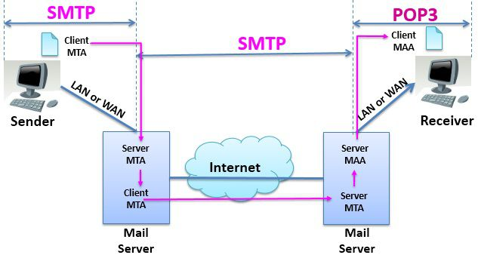The POP3 protocol operates in two modes, the **delete mode** and the **keep mode**. The POP3 protocol operates on **delete mode** when the user is working on its **permanent computer**. In delete mode, once the mail is retrieved from the mailbox it gets deleted from the mailbox permanently. The mail retrieved from the mailbox is organized on the user’s computer.

The POP3 protocol operates on**keep mode** when the user is **not working on its permanent or primary computer**. In keep mode, the mail remains in the mailbox even after its retrieval. The mail is read by the user, but it is kept in the mailbox for later retrieval and organizing of mail on users permanent computer.

Definition of IMAP

Internet Mail Accessing Protocol (IMAP) is also a **mail accessing agent** like POP3. But it is more powerful, has more features and is more complex than POP3. The POP3 protocol was found deficient in many ways. So IMAP  is introduced to overcome these deficiencies.

POP3 does not allow a user to organize mails on the mailbox. The user can not create different folders on the server. The user can not partially check the content of emails before downloading them. The user has to download an email to read it, in POP.

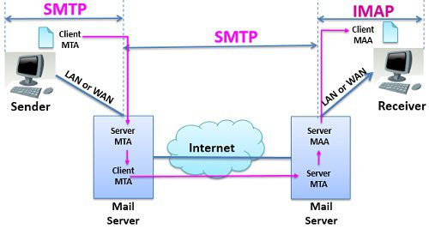IMAP is used to access the mail from the mailbox at the mail server. Using IMAP the user can check the **email header** before downloading it. The user is able to check the content of the email for a **particular string of character** that too before downloading the email.

In case, the bandwidth is limited, using IMAP the user can **partially download** the mail. It is useful in case the email contains multimedia with high bandwidth requirement. The user can create, delete or rename the mailboxes on the server. The user can also create a hierarchy of these mailboxes in a folder. This is how IMAP is more powerful than POP3 protocol.

Key Differences Between POP3 and IMAP

1. The key difference between the POP3 and IMAP is that using POP3 protocol the user has to **download** the mail before accessing it whereas, using IMAP protocol user can **partially** check the content of mail prior downloading it.
2. Using IMAP protocol user can**organize emails** on the server which can not be done using POP3.
3. Using IMAP protocol the user can **create, delete or rename** the mailboxes, even the user can create a **hierarchy of mailboxes** in the folder, but it is not possible using POP3.
4. POP3 protocol does not allow you to search the content of mail for a **particular string of character prior downloading** whereas, using IMPA user can search the content of an email for a specific string of character before downloading.
5. IMAP allows a user to **download** the mail **partially** in the case of limited bandwidth. However, this function is not available in POP3.
6. POP3 is simple and has limited functionality whereas, IMAP is powerful, complex and have extra functions over POP3.

Conclusion:

Bothe POP3 and IMAP are the message accessing protocols. But IMAP is more powerful and has many advanced features over POP3.